Graduation Project: Smart Home System

# Introduction

In this paper, we discuss and demonstrate the steps taken and the architecture behind it, in order to design a Smart Home System using Embedded C on the AVR microcontroller Atmega32. In short, this is a graduation project for the Amit Embedded Systems Diploma, in which we implement a simulation of a smart home system design, offering the user the ability to communicate a specific command from one end through a virtual terminal to a receiving end, that would in turn implement a specific action.

Moreover, in order to increase readability and ease of understanding, flowcharts are used to explain the steps taken to reach the desired objective.

# Architecture

## Description of Layered Architecture

Firstly, in order to implement the concept of layered architecture in our program, we need to understand the different layers and figure out how the program maps to such layers. As show below, there are mainly three different layers, the first being Application Layer, the second is called Hardware Abstraction Layer, and the third is the Microcontroller Abstraction Layer.

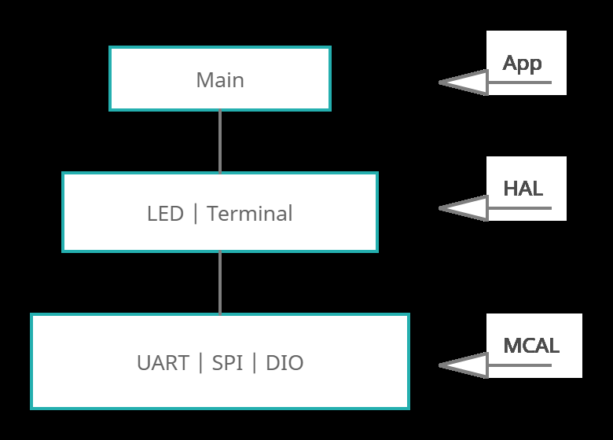

## Application Layer

In this layer, the main represents the flow of the whole program from start to finish. Below, is a flowchart that describes how the main functions. It is important to point out that the main or in other words the Application Layer, only interacts with the Hardware abstraction layer.

Moreover, the flowcharts describes both sides of the program each side being a different ECU.

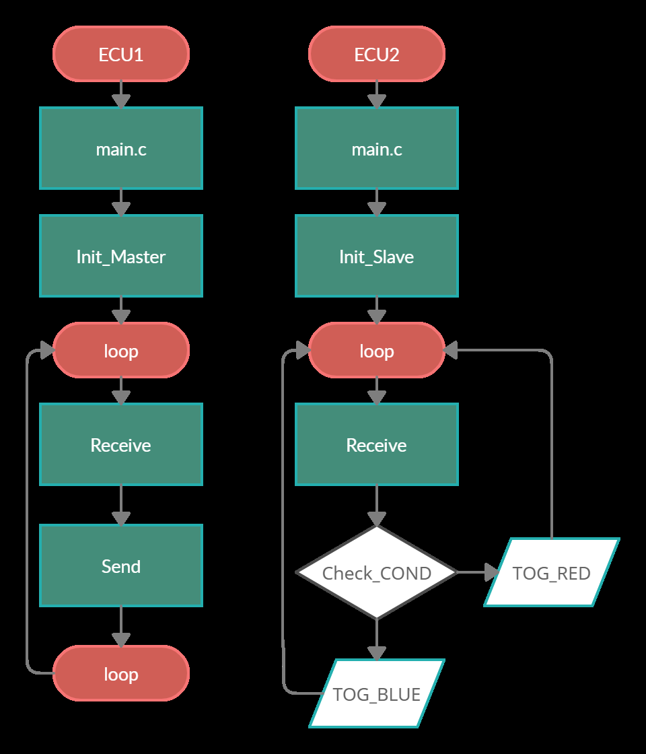

## Hardware Abstraction Layer

After the functions in main are executed, the HAL connects both the application and the MCAL together through its own functions. However, in our project there are two different Hardware Abstraction Layers, one for each ECU. In case of the Master, the HAL is called the Terminal which represents the virtual terminal in the simulation. While, for the Slave, the HAL is called the LED and it represents the RED and BLUE LEDs of the simulation.

## MCAL Layer

Finally, the Microcontroller Abstraction Layer, in which, the modules for this DIO, SPI and UART and are represented. Here, the functionality of the program is established through the use of such modules. The UART is an interfacing technique, used is this case to communicate between the virtual terminal and the first microcontroller or ECU1. Moreover, the Serial Peripheral Interface or SPI, is used in both ECUs. In the Master ECU1, sending the data received from the terminal to the Slave ECU2. Finally, the DIO module controls the functionality of each pin on the Atmega32, thus, enabling and disabling the LEDs on demand by the user.

# Conclusion

To Conclude, in this paper we illustrated how a smart home system can be implemented using Serial Communication, as well as, Serial Peripheral interface to control light fixtures using a smart device, or in case of our simulation, controlling LEDs using a Virtual Terminal. Additionally, for future work we could further enhance this system by connecting not only the MOSI (Master Output Slave input) but, also the MISO (Master Input Slave Output) pins and have the Slave return back a signal identifying the which one of the LEDs (Red or Blue) have been toggled and what is its current state.